ONLINE BAG SELLING SYSTEM

A project submitted to

**BABU MADHAV INSTITUTE OF INFORMATION TECHNOLOGY**

**Bachelors of Science**

in

**Information Technology**

for

**5 Years Integrated M.Sc. (IT)/B.Sc.(IT)**

By

**<Student name>**

**MOTISARIYA ANKUSH BHARATBHAI**

202106100110152

**Semester -3rd - B**



**Babu Madhav Institute of Information Technology**

**Uka Tarsadia University**

**Bardoli – 394350**

**Table of Content**

|  |  |  |  |
| --- | --- | --- | --- |
| **Chapters** | **Particulars** | | **Page no.** |
| **1** | **Introduction** | |  |
| 1.1 | Problem Definition/ Identification of need  Project Definition | 1 |
| 1.2 | Project objective | 2 |
|  | 1.3 | Project scope | 2 |
|  | | | |
| **2** | **System specific requirements** | |  |
| 2.1 | Functional requirements | 2 |
| 2.2 | User characteristics | 3 |
|  | | | |
| **3** | **System Analysis** | |  |
| 3.1 | Questionnaires | 5 |
|  | 3.2 | Data Flow Diagram  3.2.1 Context level DFD  3.2.2 Zero level DFD  3.3.3 First level DFD ( Any 2 major process) | 5  6  7  8 |
|  | 3.3 | Data Dictionary | 9 |
|  | | | |
|  | | | |
| **4** | **System Design** | |  |
| 4.1 | Database Design  4.1.1 Data dictionary | 10  10 |
|  | 4.2 | Interface Design  4.2.1 Input form  4.2.2 Output form | 11  12  14 |
| **5** | **Learning during Project Work** | | 16 |
|  |  | |  |

**CHAPTER: 1**

**Introduction**

|  |  |  |
| --- | --- | --- |
| 1.1 | Problem Definition/ Identification of need   * **When this kind of system not people want to go physical shop to buy bag not only that it may chance that customer not find thee recommended bag or product.** * **Some remote areas has do not have any branded bag shop.**     **Project Definition**   * **where different type of bags will be uploaded ad customer can book or buy the bags from this website.** * **Here they can find a various kind of bag with different categories and discound.**   **1.2 project objective**   * **The main objective is to elimite the dealer from this website and provide to sell order to advertise their own branded bag.**   **1.3 project scope**     * **This system is able to help all the customer accorsse whole coutry as this also here fucility to deliver the product accorss the counting.**   **CHAPTER: 2**  **System specific requirements**  **2.1 Functional requirements**   * **Registration** * **Login** * **Mange orders** * **Payment** * **Rating** * **Add to cart** * **Selling price** * **Take the order**   **Users of the system**   1. **Admin** 2. **Customer**   **2.2 users characteristics**   1. **Administrators**  * **Administrators are people who add or control categories for goods and are responsible for administering the vendors.**   **2.customers**     * **The end customer will be the one who visits the website and orders items online from those added by the sellers.** | |
|  | **CHAPTER: 3**  **System Analysis**   |  |  | | --- | --- | | 3.1 | Questionnaires | |  | **Questionnaires**   * **what is process of registration. (open)** * **what is process of delivery. (open)** * **what are the extra functionality you want to give to the delivery pageant. (close)** * **what is the scope of system. (close)** * **what is budget of the system. (scalar)** * **How do you want to get review. (torobe)** * **Do you want weekly monthly selling reports. (bipolar)** * **What is process of payment. (open)** * **What type of bag you are having. (close)** | |  |  | | 3.2 | Data Flow Diagram | | 3.2.1 | Context level DFD | | |
|  |  | |
|  |  | |
|  |  | |
|  |  | |
|  |  | |
|  | |  |  | | --- | --- | | 3.2.2 | Zero level DFD | | |
|  |  | |
|  |  | |
|  | |  |
|  | |  |
|  | |  |
| 3.2.3 | | First level DFD ( Any 2 major process) |
|  | | Process : 1 order |
|  | | Process:2 PAYMENT |
|  | |  |

**CHAPTER: 4**

**System Design**

|  |  |
| --- | --- |
| 4.1 | Database Design  **USER MASTER:** User id+  User name+  Password+  Gender+  Address  **CUSTOMER MASTER:** cust id+  Cust name+  Password+  Gender+  Address+  Email+  Con no  **REGISTER MASTER**: User id+  User name+  Password+  **BAG MASTER:**  bag id+  Name+  Order id+  Price+  quantity  **ORDER MASTER:**  order id+  Order name+  User id+  Payment id+  Address    **PAYMENT MASTER**: payment id+  Order id+  Amount+  **FEEDBACK MASTER:** feedback id+  User id+  Feedback |
| 4.1.1 | Data dictionary |
|  | Table name : USER MASTER  Table description : USER DETAILS TABLE ALL THE INFORMATION ABOUT USERS LIKE  ID,NAME,PASSWORD,GENDER,ADDRESS ETC.   |  |  |  |  |  |  |  |  |  |  | | --- | --- | --- | --- | --- | --- | --- | --- | --- | --- | | **Field Name** | **Data Type** | **Field Size** | **Constrains** | **Description** |  |  |  |  |  | | USER_ID  USER_NAME  PASSWORD  GENDER  ADDRESS | INT  VARCHAR  VARCHAR  VARCHAR  VARCHAR | -  50  15  5  15 | PRIMARYKEY  NOTNULL  NOTNULL  NOTNULL  NOTNULL | IDENTIFIES UNIQUE  ID OF USER  SPECIFIES UNIQUE  USERNAME(EMAIL)  OF USER  PASSWORD OF  USER  GENDER OF  USER  ADDRESS OF  USER |  |  |  |  |  |   Table name : USER MASTER  Table description : CUSTOMER DETAILS TABLE ALL THE INFORMATION ABOUT CUSTOMER LIKE  ID,NAME,PASSWORD,GENDER,ADDRESS ETC.   |  |  |  |  |  |  |  |  |  |  | | --- | --- | --- | --- | --- | --- | --- | --- | --- | --- | | **Field Name** | **Data Type** | **Field Size** | **Constrains** | **Description** |  |  |  |  |  | | CUST_ID  CUST_NAME  PASSWORD  GENDER  ADDRESS  EMAIL_ID  CON _NO | INT  VARCHAR  VARCHAR  VARCHAR  VARCHAR  VARCHAR  INT | -  50  15  5  15  15  - | PRIMARYKEY  NOTNULL  NOTNULL  NOTNULL  NOTNULL  NOT NULL  NOT NULL | IDENTIFIES UNIQUE  ID OF CUST  SPECIFIES UNIQUE  CUSTNAME  OF CUST  PASSWORD OF  CUST  GENDER OF  CUST  ADDRESS OF  CUST  EMAIL OF  CUST  CON OF CUST |  |  |  |  |  |     Table name : REGISTER MASTER  Table description :REGISTER MASTER CAN STORE REGISTRATION DETAILS   |  |  |  |  |  | | --- | --- | --- | --- | --- | | **Field Name** | **Data Type** | **Field Size** | **Constrains** | **Description** | | USER_ID  USER_NAME  PASSWORD | INT  VARCHAR  VARCHAR | -  50  50 | FK  FK  FK | REFERENCED  FROM USER  TABLE(USER_ID)  REFERENCED  FROM USER  TABLE(USER_NAME)  REFERENCED  FROM USER  TABLE  (USER_PASSWORD | |  |  |  |  |  | |  |  |  |  |  |   Table name : BAG MASTER  Table description :BAG_MASTER TABLE USE TO MANG ALL INFORMATION ABOUT BAG AND ALSO MANGE ITEM.   |  |  |  |  |  | | --- | --- | --- | --- | --- | | **Field Name** | **Data Type** | **Field Size** | **Constrains** | **Description** | | BAG_ID  NAME  ORDER_ID  PRICE  QUANTITY | INT  VARCHAR  INT  FLOAT  INT | -  15  -  -  - | PRIMARY KEY  NOTNULL  FK  NOT NULL  NOT NULL | IDENTIFIES  UNIQUE ID OF  BAG  SPECIFIED NAME  OF ITEM  REFERENCED  FROM ORDER  TABLE(ORDER_ID)  PRICE OF ITEM  QUANTITY OF ITEM | |  |  |  |  |  |   Table name : ORDER MASTER  Table description : ORDER_MASTER CONTAIN ORDER DETAILS AND STATUS.   |  |  |  |  |  | | --- | --- | --- | --- | --- | | **Field Name** | **Data Type** | **Field Size** | **Constrains** | **Description** | | ORDER_ID  ORDER_NAME  USER_ID  PAYMENT_ID  ADDRESS | INT  VARCHAR  INT  INT  VARCHAR | -  15  -  -  50 | PRIMARY KEY  NOTNULL  FK  FK  NOTNULL | IDENTIFIES  UNIQUE ID OF  ORDER  SPECIFIED NAME  OF ORDER  REFERENCED  FROM USER  TABLE(USER_ID)  REFERENCED  FROM PAYMENT  TABLE  (PAYMENT_ID)  SPECIFIED  ADDRESS  OF ORDER | |  |  |  |  |  |   Table name : PAYMENT MASTER  Table description :PAYMENT_MASTER USE FOR PAYMENT DETAILS.   |  |  |  |  |  | | --- | --- | --- | --- | --- | | **Field Name** | **Data Type** | **Field Size** | **Constrains** | **Description** | | PAYMENT_ID  ORDER_ID  AMOUNT | INT  INT  FLOAT | -  -  - | PK  FK  NUTNULL | IDENTIFIES  UNIQUE ID OF  PAYMENT  REFERENCED  FROM ORDER  TABLE(ORDER_ID)  AMOUNT OF  PAYMENT | |  |  |  |  |  |   Table name : FEEDBACK MASTER  Table description : FEEDBACK_MASTER HAVE ALL THE FEED BACK OF ORDER WHICH  IS GIVEN BY CUSTOMER   |  |  |  |  |  | | --- | --- | --- | --- | --- | | **Field Name** | **Data Type** | **Field Size** | **Constrains** | **Description** | | FEEDBACK_ID  USER_ID  FEEDBACK  ORDER_ID | INT  INT  VARCHAR  INT | -  -  200  - | PRIMARY KEY  FOREIGN KEY  NOTNULL  FOREIGN KEY | SPECIFIED  FEEDBACK ID  REFERENCED  FROM USER  TABLE(USER_ID)  SPECIFIED  CUSTOMER  FEEDBACK  REFERENCED  FROM ORDER  TABLE(USER_ID) | |  |  |  |  |  | |
| 4.2 | Interface design  Input form |
|  |  |
|  |  |

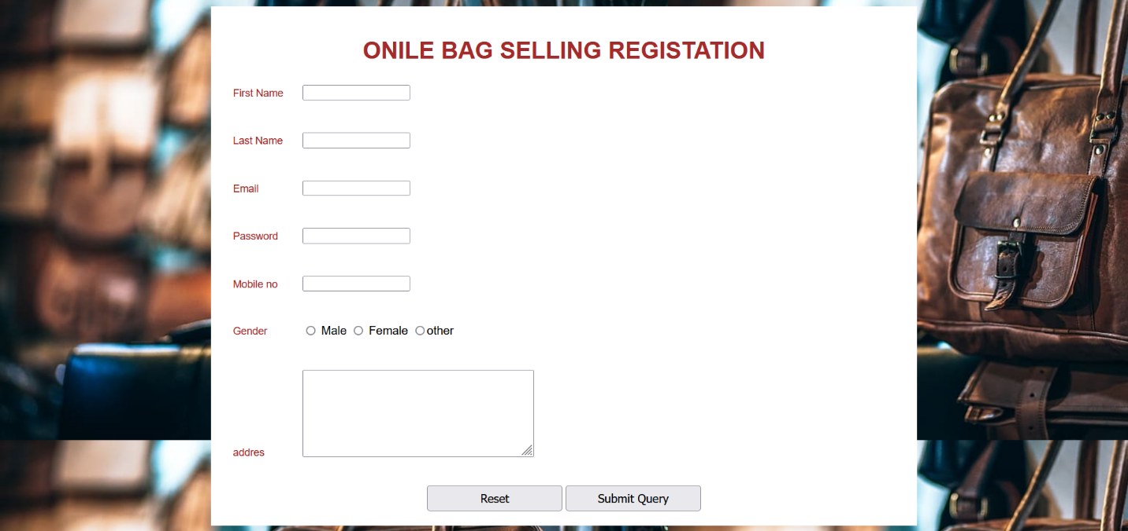

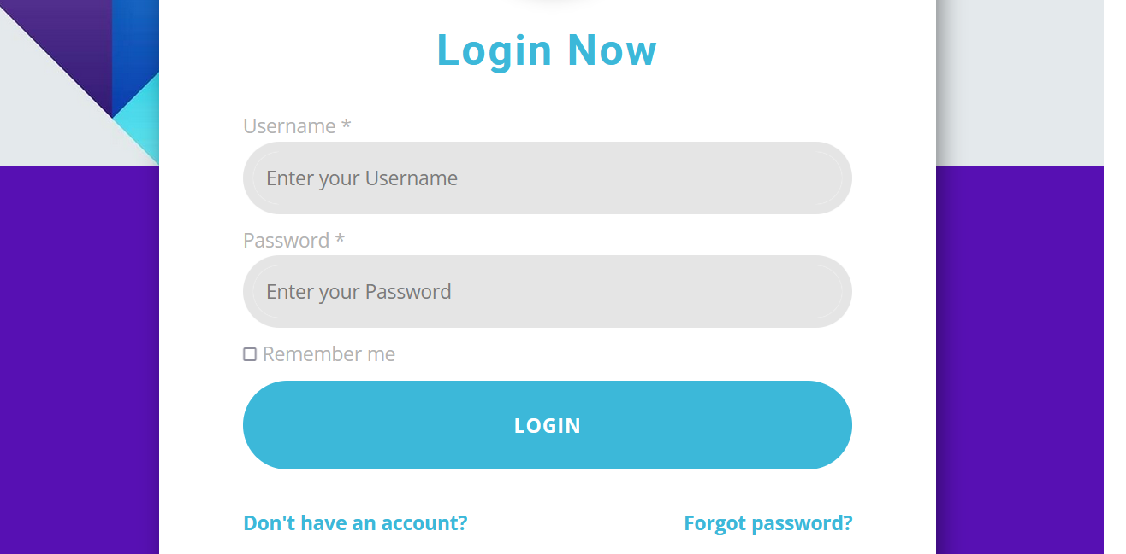

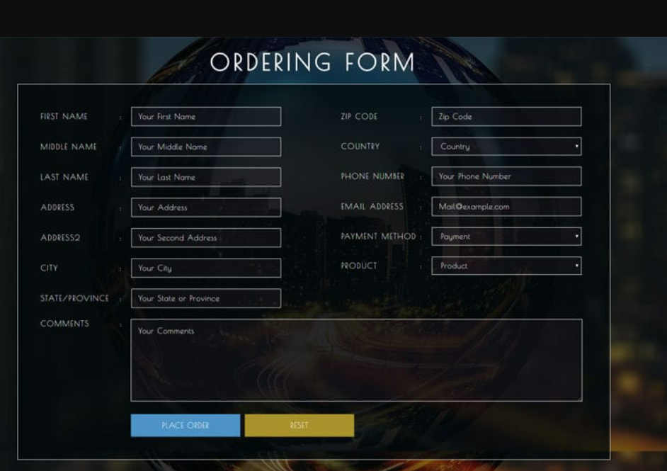

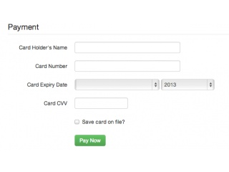

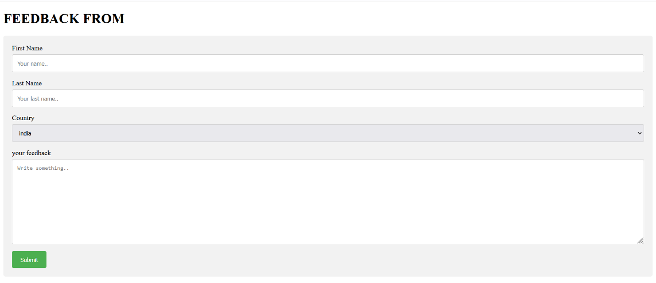

**Out put from**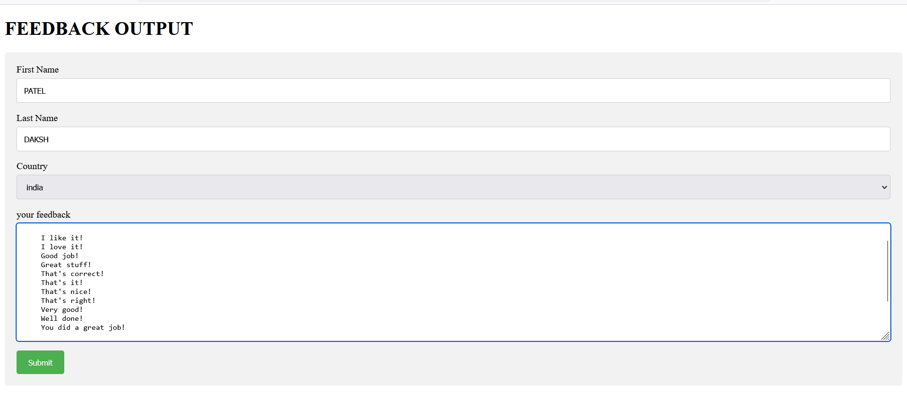

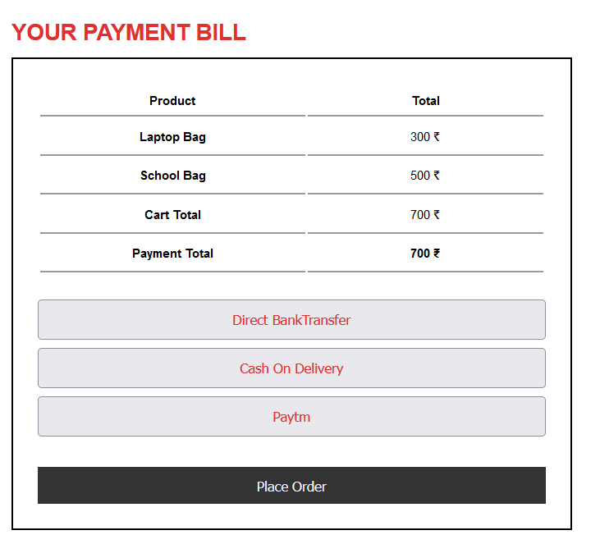

**CHAPTER: 5**

**Learning during Project Work**

* **I Learn lots of things like if we want to make any system then first we have to understand that what is the first step we can take as a system analyst.**
* **I learn how to make documentation of system. In that system functionalities, Questionnaires, date base(table, table description ) input and output from etc…**